**Code -**

import hashlib

import datetime

import json

from flask import Flask, jsonify

class Blockchain:

def __init__(self):

self.chain = []

self.create_block(proof=1, previous_hash='0')

def create_block(self, proof, previous_hash):

block = {

"index": len(self.chain) + 1,

"timestamp": str(datetime.datetime.now()),

"proof": proof,

"previous_hash": previous_hash

}

self.chain.append(block)

return block

def get_previous_block(self):

return self.chain[-1]

def proof_of_work(self, previous_proof):

new_proof = 1

check_proof = False

while check_proof == False:

new_hash = hashlib.sha256(str(new_proof**2 - previous_proof**2).encode()).hexdigest()

if new_hash[:4] == "0000":

check_proof = True

else:

new_proof += 1

return new_proof

def hash(self, block):

encoded_block = json.dumps(block, sort_keys=True).encode()

return hashlib.sha256(encoded_block).hexdigest()

def is_chain_valid(self, chain):

previous_block = chain[0]

block_index = 1

while block_index < len(chain):

block = chain[block_index]

if block['previous_hash'] != self.hash(previous_block):

return False

previous_proof = previous_block['proof']

proof = block['proof']

hash_operation = hashlib.sha256(str(proof**2 - previous_proof**2).encode()).hexdigest()

if hash_operation[:4] != '0000':

return False

previous_block = block

block_index += 1

return True

app = Flask(__name__)

blockchain = Blockchain()

@app.route('/mine_block', methods=['GET'])

def mine_block():

previous_block = blockchain.get_previous_block()

previous_proof = previous_block['proof']

proof = blockchain.proof_of_work(previous_proof)

previous_hash = blockchain.hash(previous_block)

block = blockchain.create_block(proof, previous_hash)

response = {'message': 'A block is MINED',

'index': block['index'],

'timestamp': block['timestamp'],

'proof': block['proof'],

'previous_hash': block['previous_hash']}

return jsonify(response), 200

@app.route('/get_chain', methods=['GET'])

def display_chain():

response = {'chain': blockchain.chain,

'length': len(blockchain.chain)}

return jsonify(response), 200

@app.route('/valid', methods=['GET'])

def valid():

valid = blockchain.is_chain_valid(blockchain.chain)

if valid:

response = {'message': 'The Blockchain is valid.'}

else:

response = {'message': 'The Blockchain is not valid.'}

return jsonify(response), 200

app.run(host='127.0.0.1', port=5000)

**Output-**

1. Mine Block.

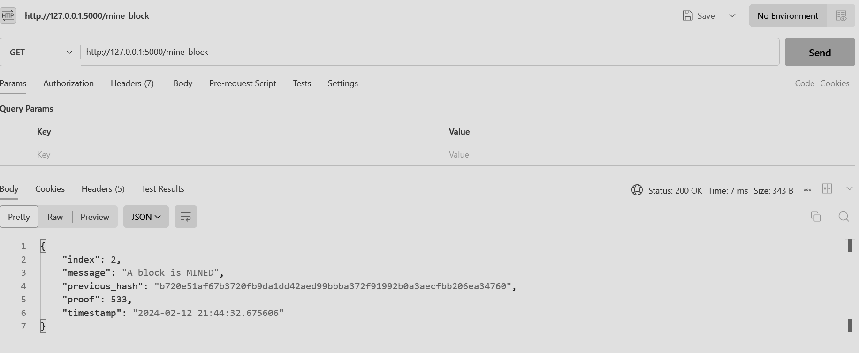

1. Print Chain.

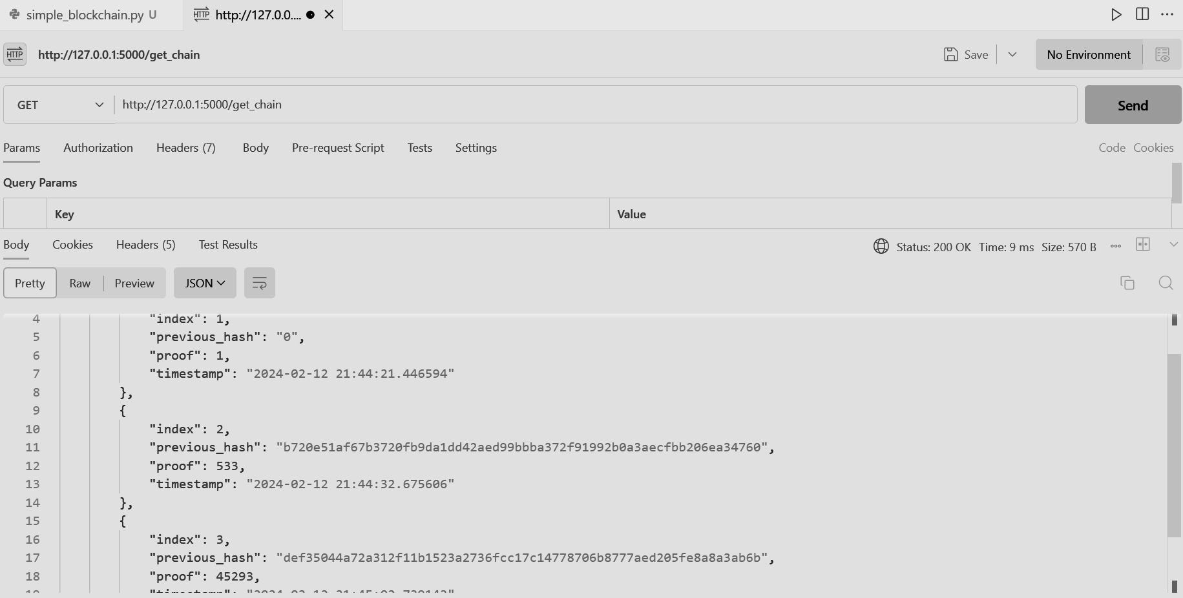

1. Valid Chain.

